HUMA Analysis

<https://journals.lww.com/jtrauma/fulltext/2023/08000/evaluation_of_vascular_repair_by_tissue_engineered.11.aspx>

* HUMA released pre-clin study looking at ATEV/ HAV vs ePTFE in porcine model
* N=36 pigs, 4 treatment groups
  + receiving either the HAV or a PTFE graft following a hind limb ischemia period of either 0 or 6 hours
  + 3cm by 6mm
  + In right eliac artery
  + Not immune suppressed for 1st mth
  + Eval: graft patency, hind limb function, biochem markers/ histology
  + Hind limb function and tissue damage biomarkers improved?
* Multiple typos in paper
* In methods say PTFE not ePTFE
* Paper below says infection rates wont be different btwn synth and nat
* Embolisms?
* 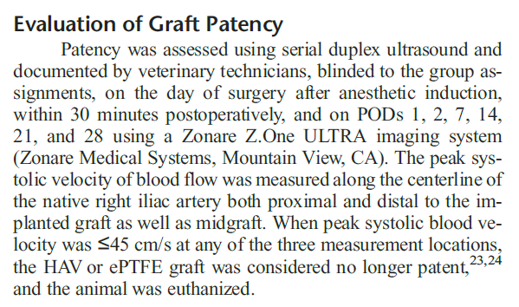

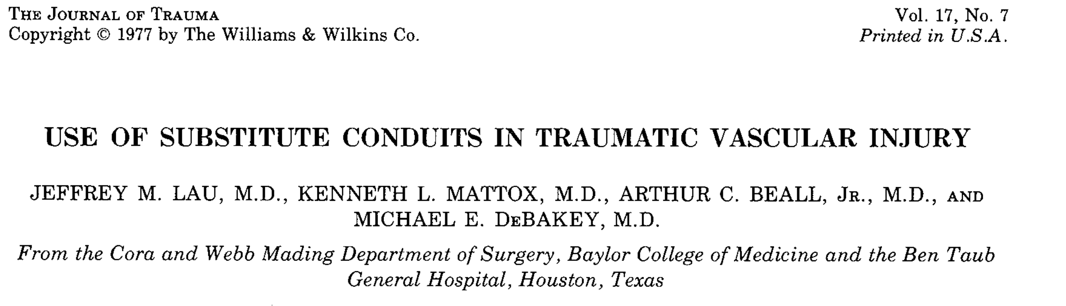

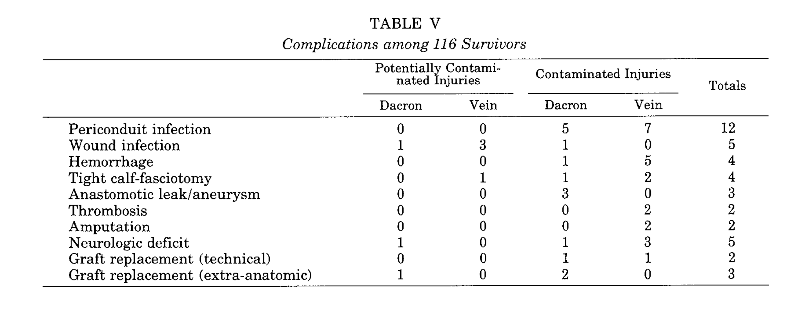

Rates of infection don’t differ much between synthetic and saphenous veins

https://www.ncbi.nlm.nih.gov/pmc/articles/PMC7768973/

* Vein grafts constituted 82% of the repairs and had a similar estimated patency of 93% compared with 81% for all other repairs.
* Proportion of scripts that are vein vs PTFE/ other?
* Upper extremity arterial cohort: Vein grafts constituted 90% of the repairs and had a patency of 97% compared with 33% for all other repairs (p<0.001; only five repairs were in this group).
* Lower extremity arterial patency: Lower extremity estimated arterial repair patency was 91% with median follow-up of 20 months

chrome-extension://efaidnbmnnnibpcajpcglclefindmkaj/https://www.fda.gov/media/158495/download

PTFE graft BLA

Meta analysis studies

Local response-

* Only have one rat study for local response.
* N=15, they report no foreign body giant cells (FBGCs) at

Devices:

* PTFE
* ePTFE
* HePTFE
  + Below-knee bypass 48mths primary patency: HePTFE 45.2% vs ASV 69%, p<0.001
  + Secondary patency: 57% HePTFE vs 67.5% ASV, p=0.1

HC Wainright call 09/10/2024

* Have treated 600 pts? Data??
* 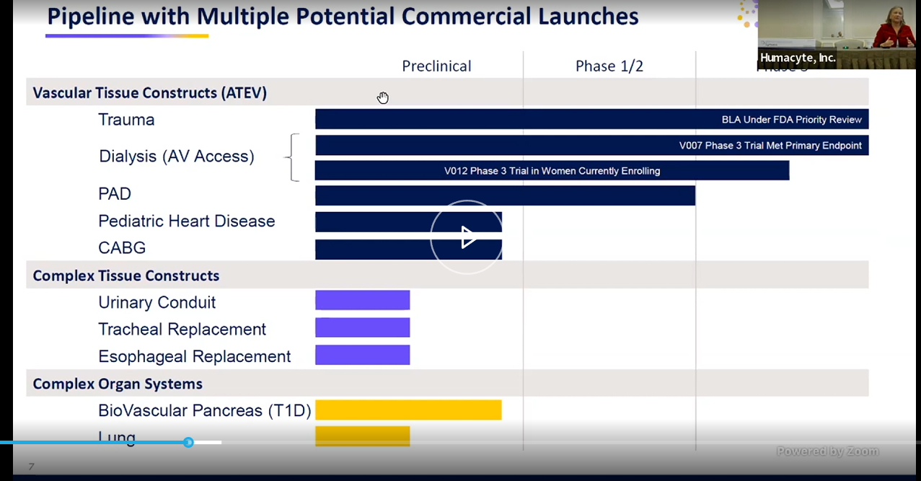
* DOD supported ph3 trial in BLA submission
* 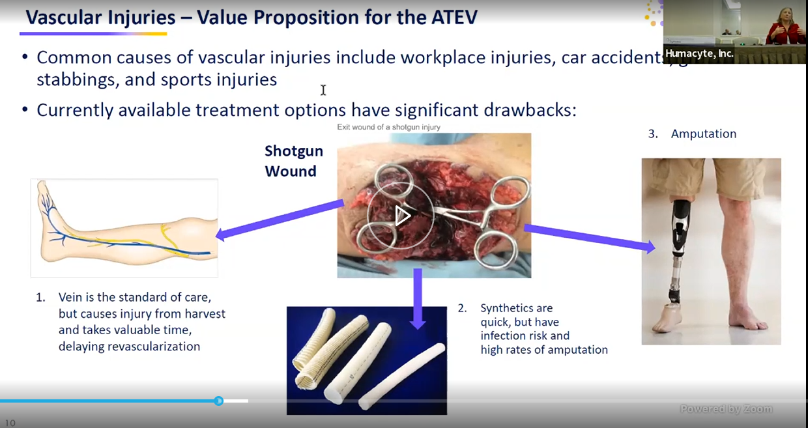
* She says infection rate is “quite high” on grafts vs their approach
* 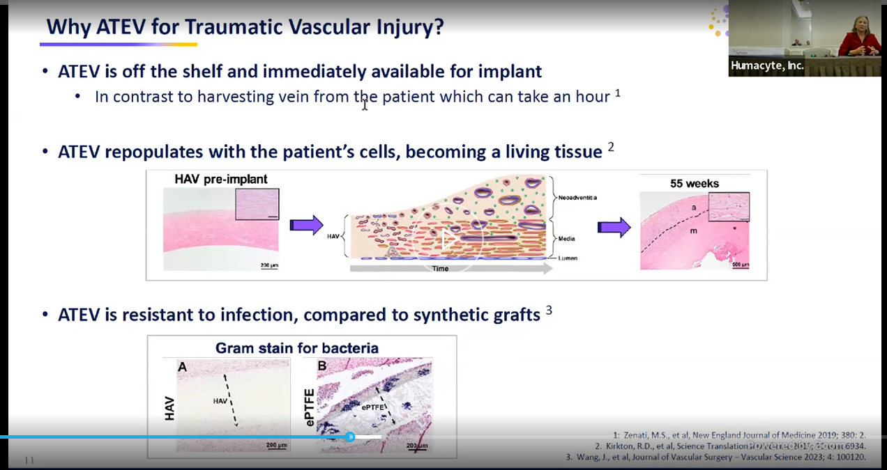
* 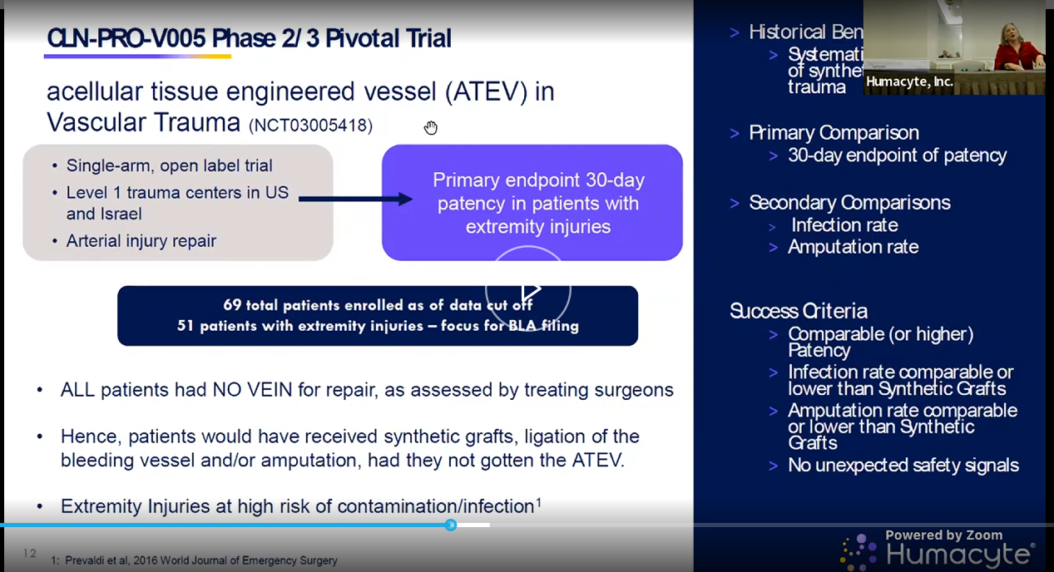
* Will follow pts for 3yrs on this study
* 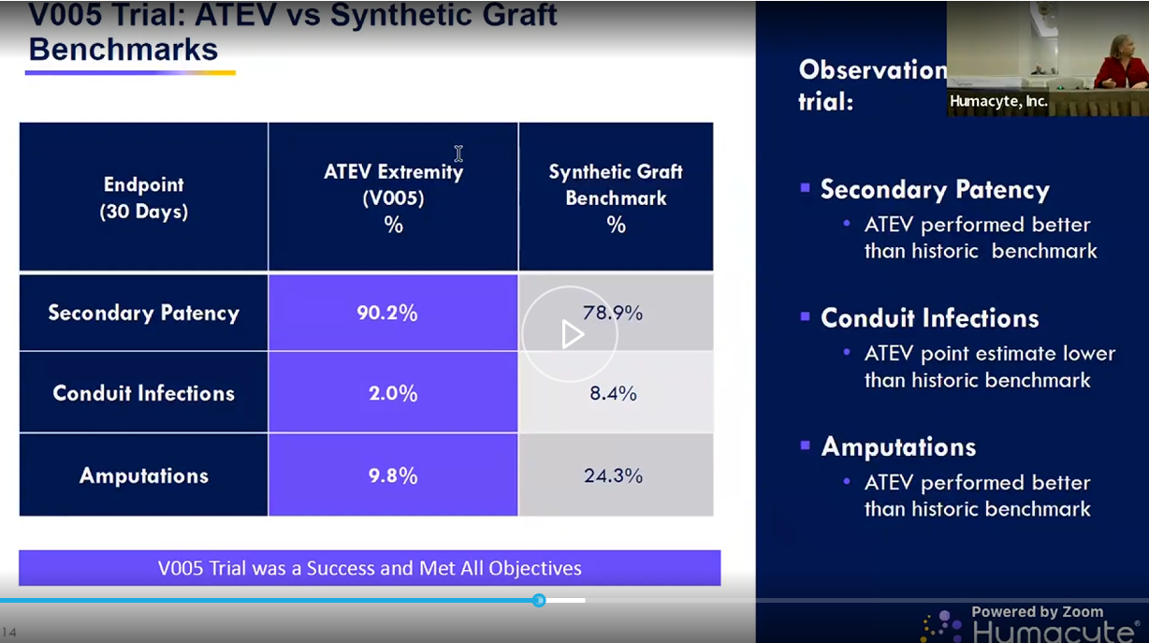
* 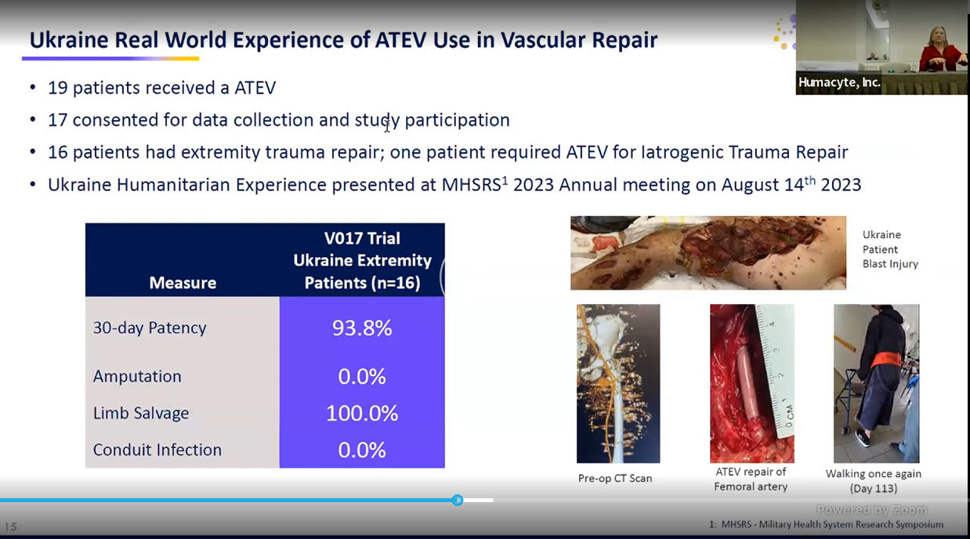
* Docs trained over zoom?
* 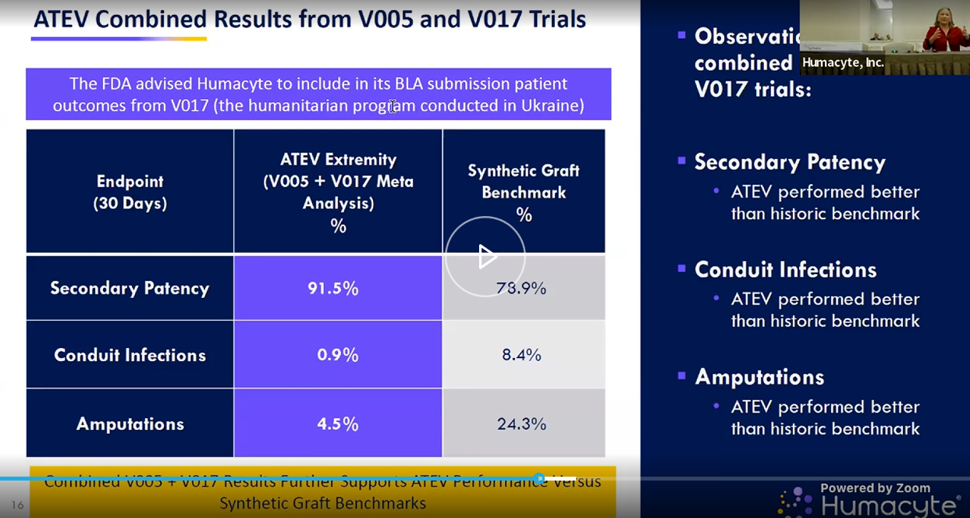
* 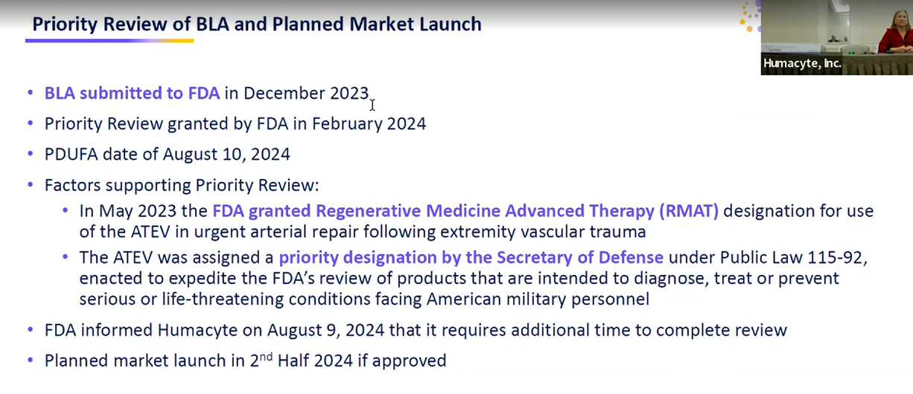
* “we’ve completed inspections and labelling talks and post approval commitments w FDA”
* “we do not have a new PDUFA data, expect to hear in coming weeks and months”
* 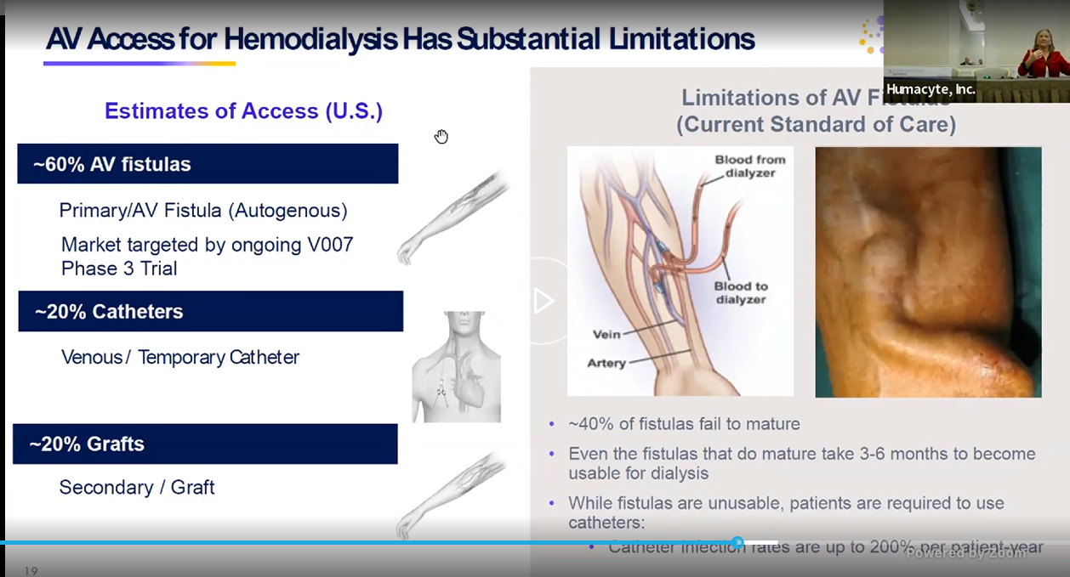
* 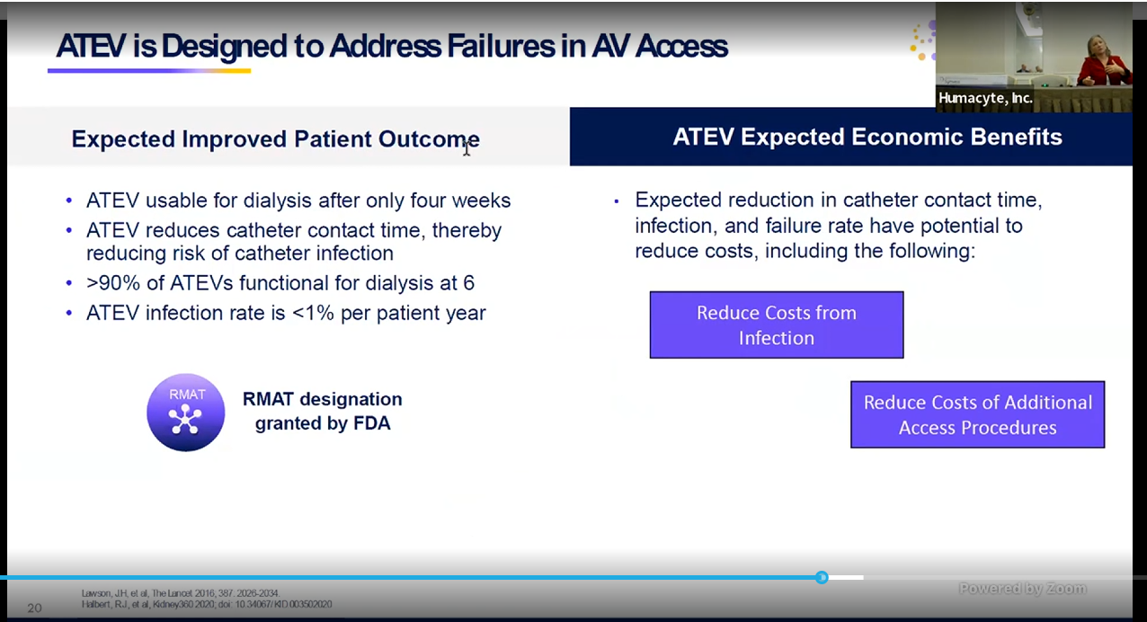
* 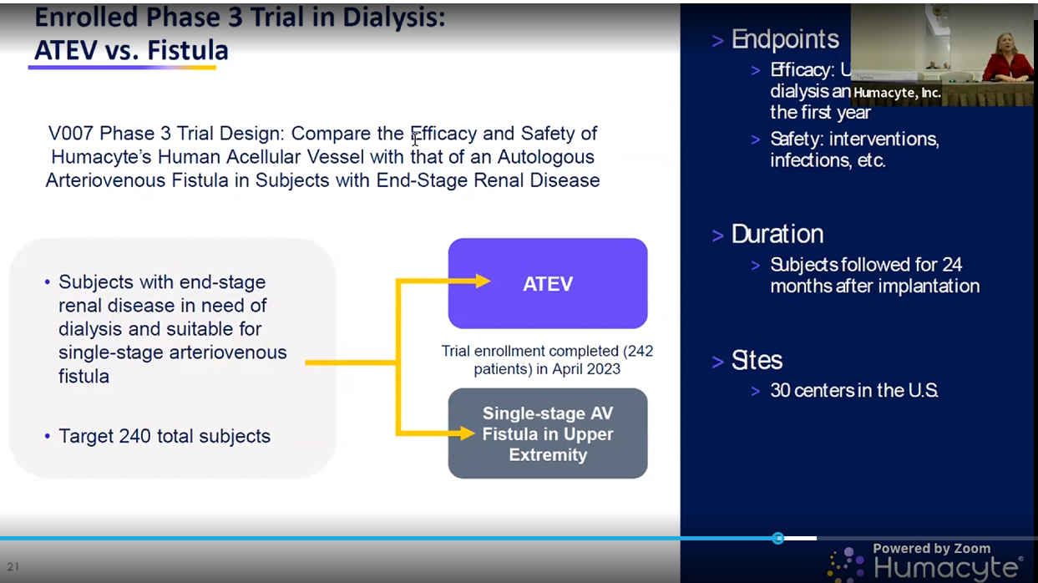
* 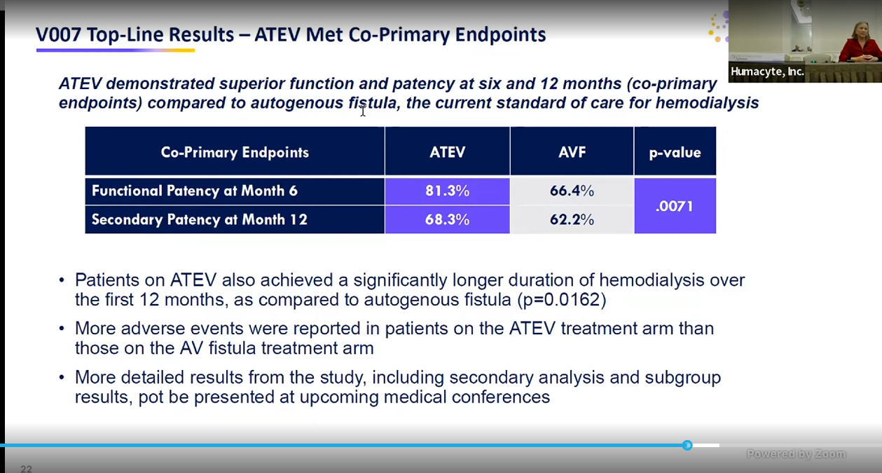
* Also have sub groups they are keen to share those with us soon! In several weeks at KOL webinar
* This study is done already
* 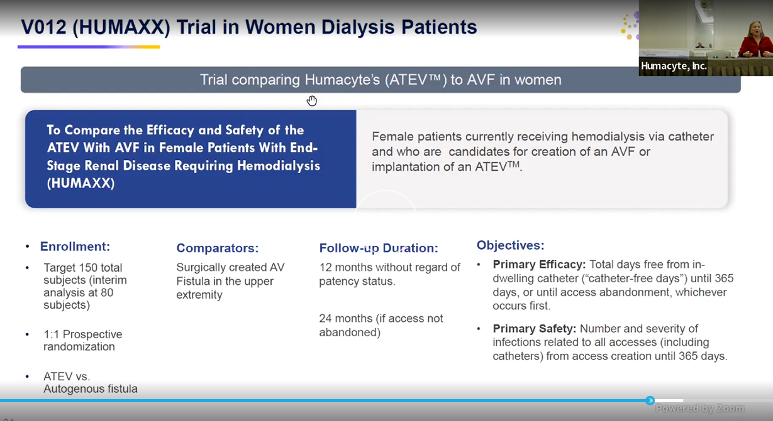
* 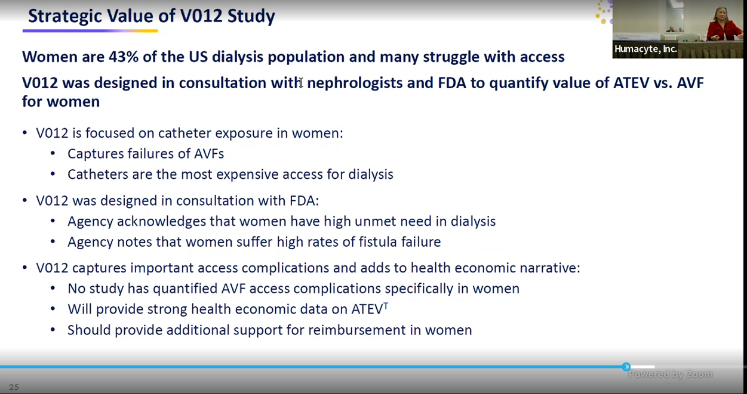
* 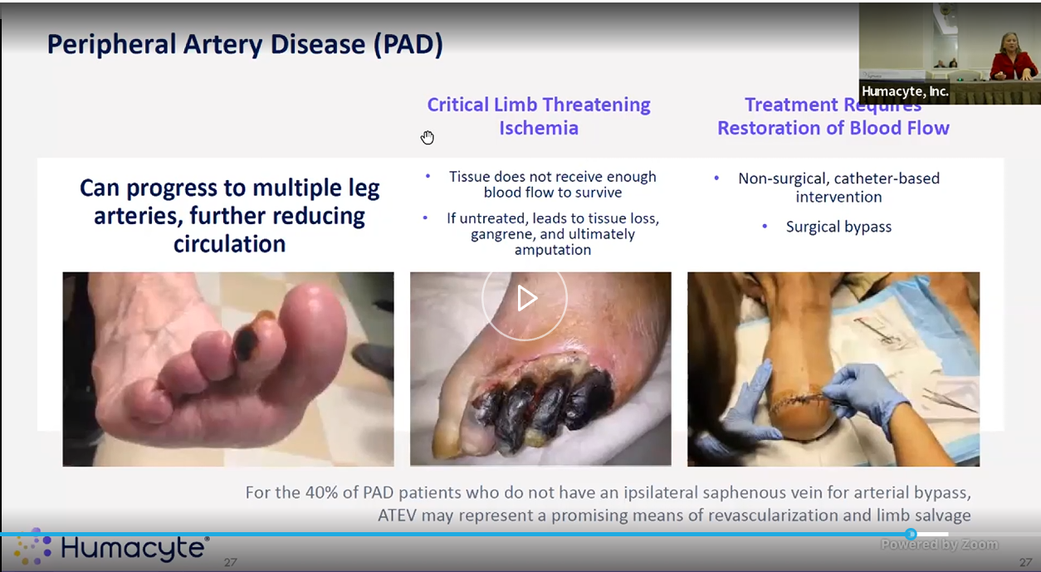
* Skipped thru the following
* 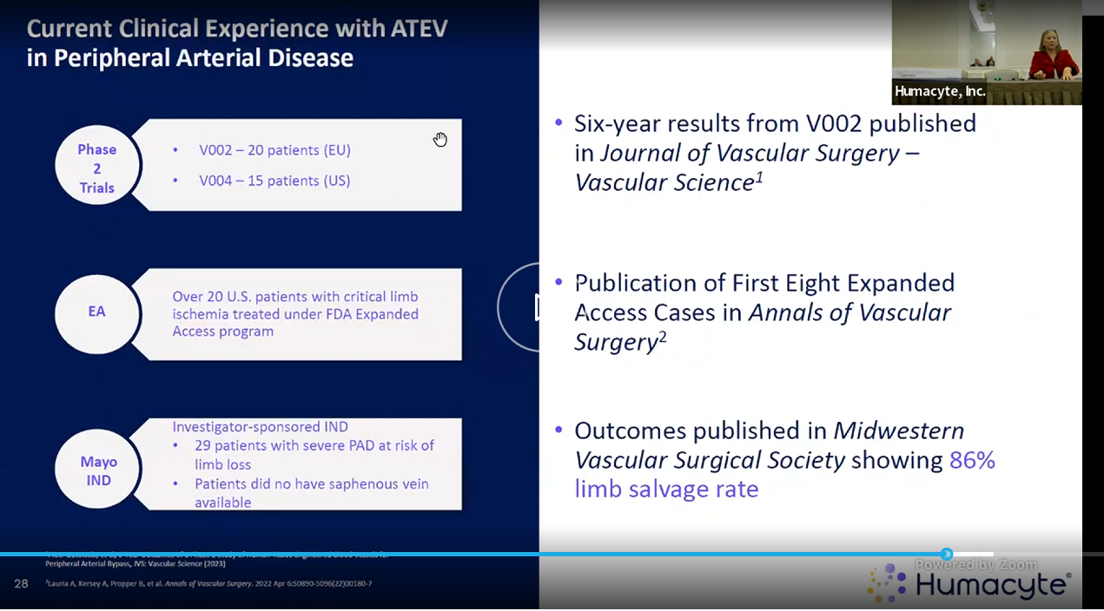
* 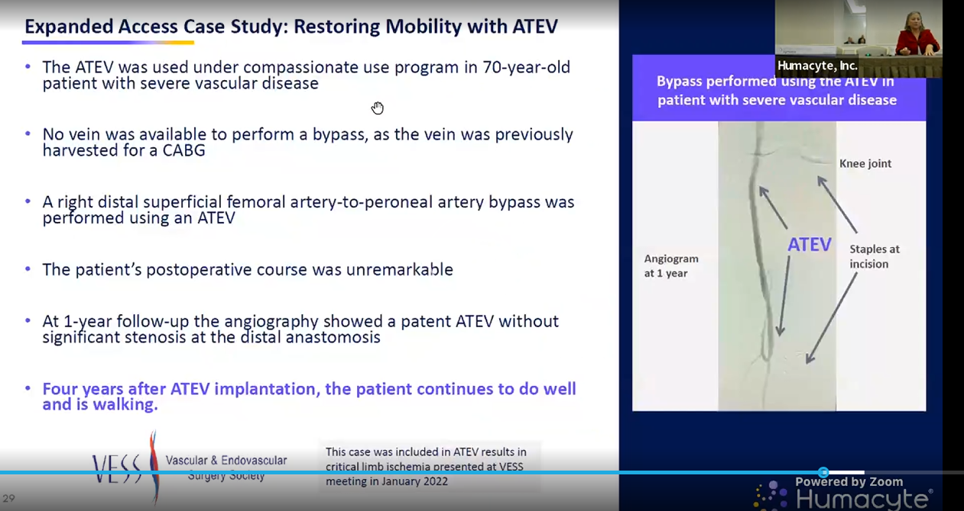
* 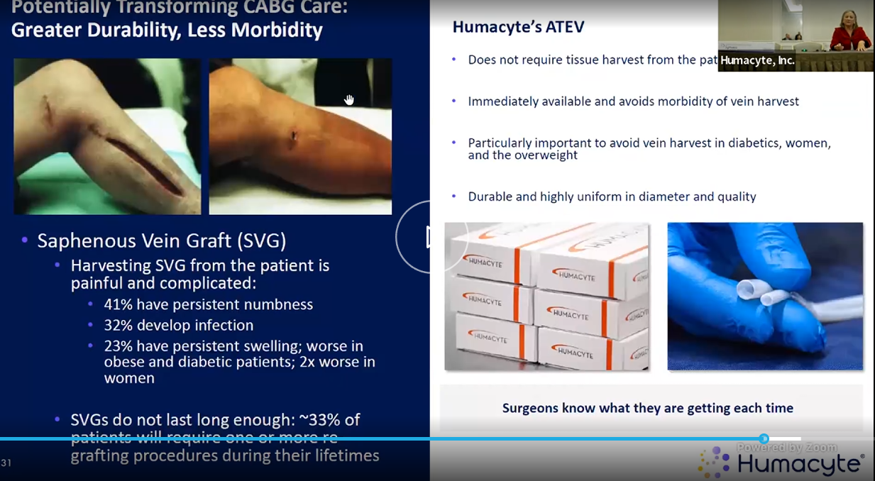
* 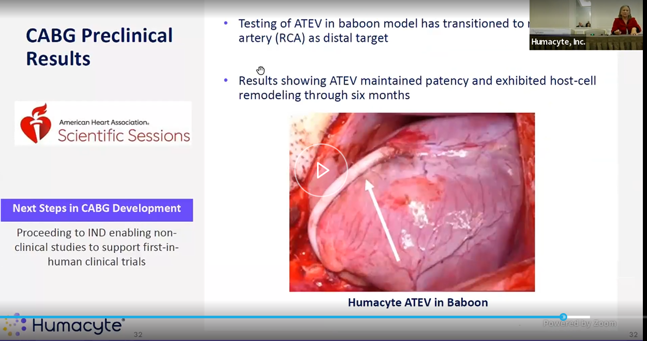
* 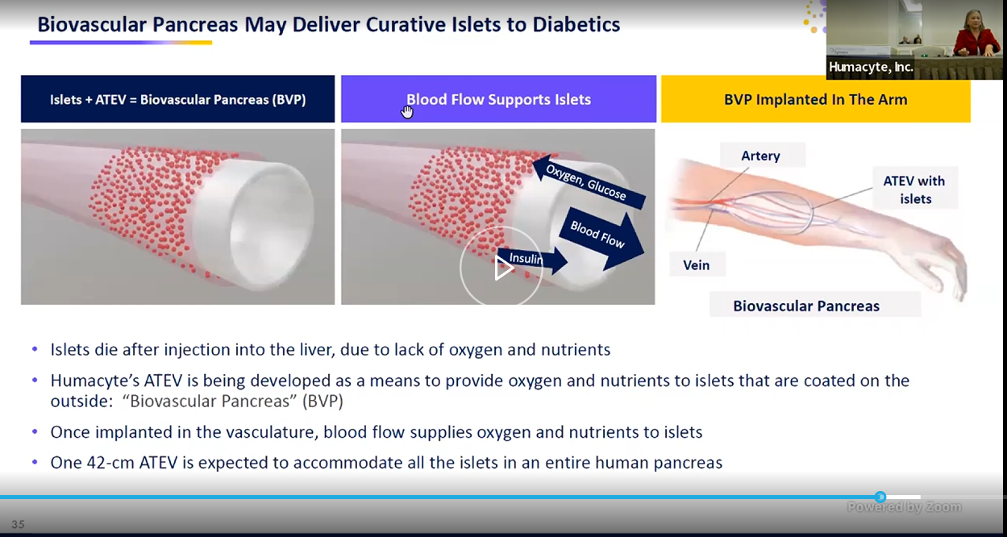
* 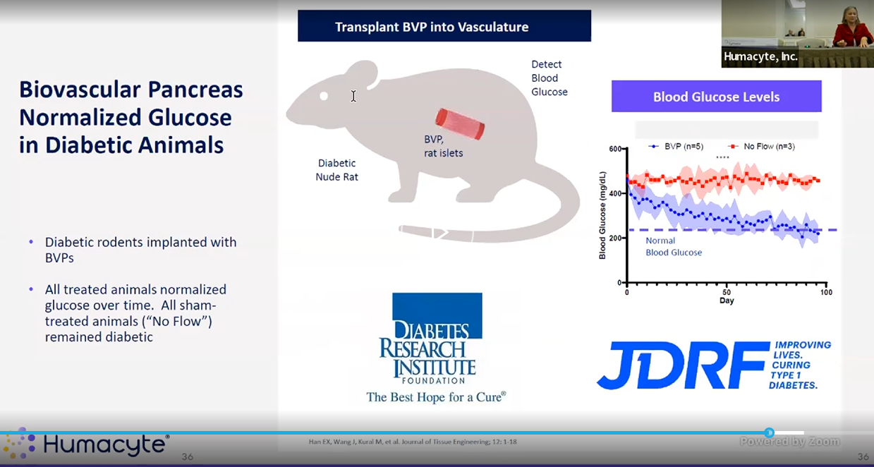
* 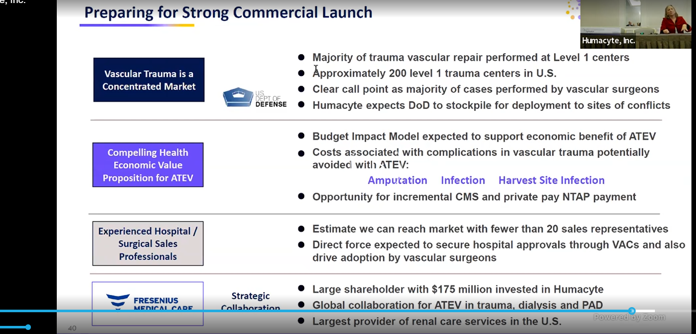
* 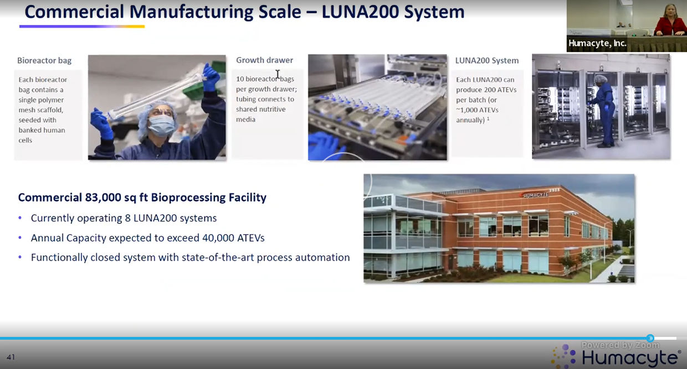
* 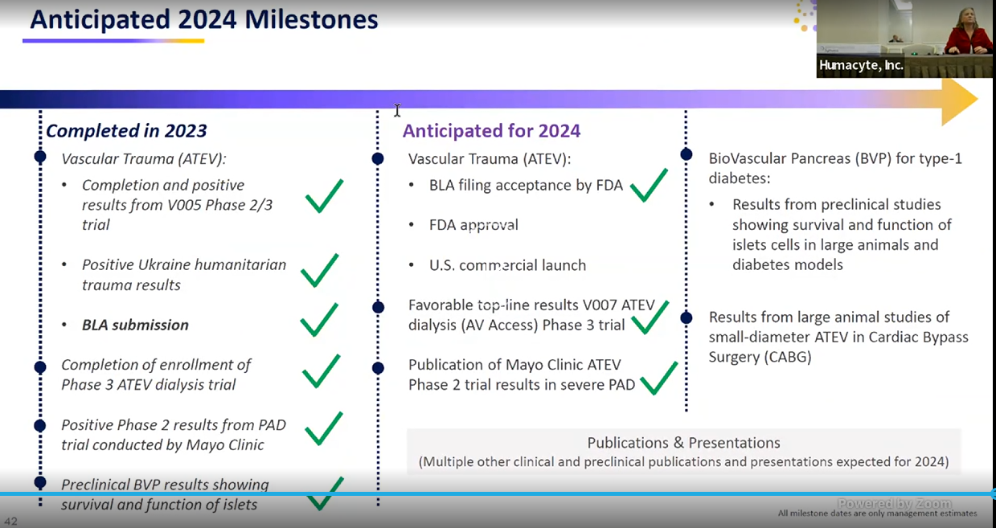
* 20% of facility is actually occupied rn. Rest can be expanded.

Patency:

Primary patency means that you perform a procedure to restore patency to a vessel, and report how long patency is maintained without any repeat intervention. Primary-assisted patency defines the durability of an intervention that failed initially but not to the level of thrombosis and was retreated. Secondary patency means that the initial intervention failed to the level of thrombosis and was retreated.

https://www.ncbi.nlm.nih.gov/pmc/articles/PMC2386712/  
**Hemodialysis Arteriovenous Fistula Patency Revisited: Results of a Prospective, Multicenter Initiative**  
Primary patency is the intervention-free access survival. Assisted primary patency is the thrombosis-free access survival. Secondary patency ends when the access is abandoned

Risk factors for primary functional patency loss (intervention-free interval) and secondary failure (abandonment) were determined using regression models.

Primary patency (intervention-free access survival) was defined as the interval from time of access placement to any intervention designed to maintain or reestablish patency or to access thrombosis or the time of measurement of patency

Assisted primary patency (thrombosis-free access survival) was defined as the interval from time of access placement to access thrombosis or time of measurement of patency, including intervening manipulations (surgical or endovascular interventions) designed to *maintain* the functionality of a patent access

Secondary patency (access survival until abandonment) was defined as the interval from time of access placement to access abandonment or time of measurement of patency, including intervening manipulations (surgical or endovascular interventions) designed to *reestablish* the functionality of thrombosed access

The word “**functional**” was added to patency to indicate that patency interval started at date of first successful cannulation for hemodialysis treatment instead of date of access placement

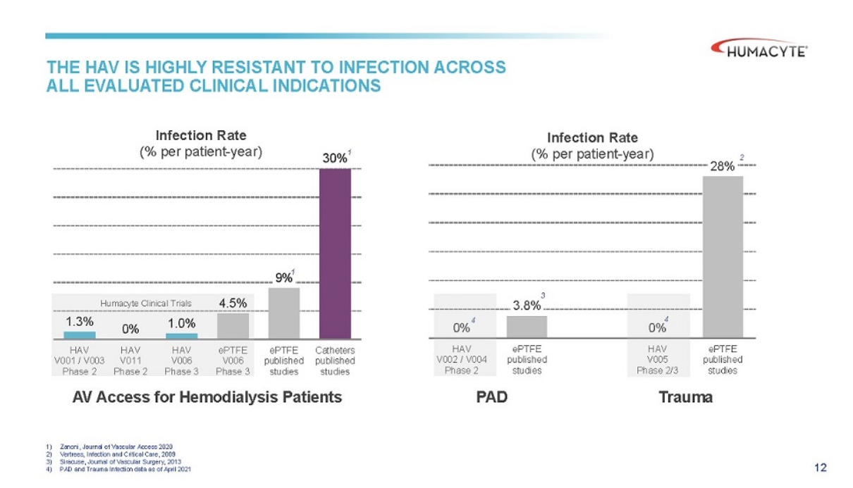

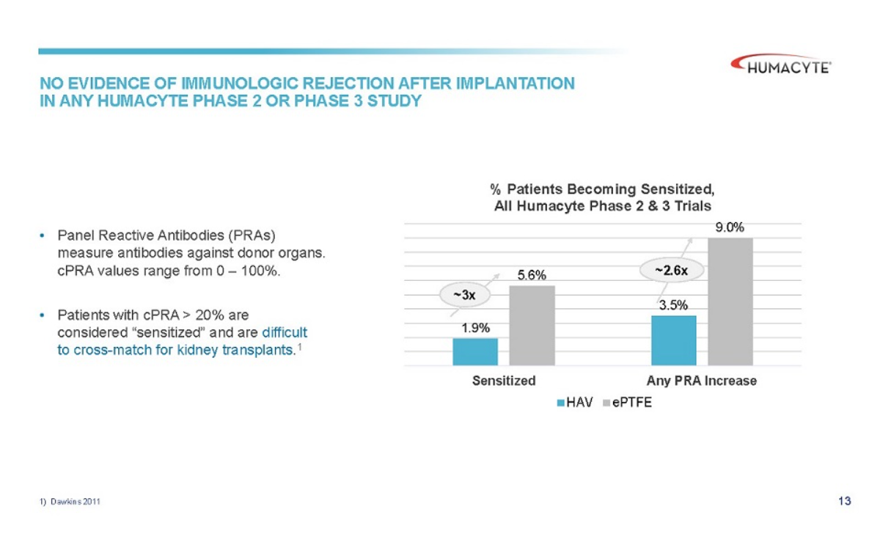

Thesis:

HUMA is a short/ sell candidate due to its lack of clinical efficacy, problematic safety data and overall lack of data for the indication they are pursuing for approval with their BLA. This thesis relies primarily on an evaluation of the clinical data of the trauma and dialysis indications.

* State the lead product, mention indications it’s pursuing.
* Set context for the indications- patency (define them), and how FDA’s mandate is to approve on safety and efficacy. We will examine both of those perspectives when considering the approval of the ATEV.
* Efficacy- trauma
  + Look at clinical data – V005, V017
    - V005
      * ~~introduction~~
      * ~~Clin readout table~~
      * ~~Inclusion exclusion criteria~~
      * ~~Endpoints~~ 
        + ~~What they are now~~
        + ~~What they started as~~
    - Historical comparisons
      * VAVIS study and data
        + Anti platelet meds
        + Patency at 30days as bridge

Argue that one

* + - * + Lower body vs upper body
        + Gunshot vs blast
      * Their own historical comparison in slides
    - Anti platelet drugs
    - V017
      * Complete lack of inc/excl
      * Ukranian, retrospective, observational
      * Highest reported data ever
      * Endpts
        + Limited time for comparison, 30d, 12m
      * N=16
* Safety- trauma
  + Amputations, infections
* Efficacy- Dialysis
  + V006
    - Endpts
      * Functional patency is a made up term
      * Secondary patency
  + V007
* Safety
  + No long term data in any case
  + Infection and amputation rates at what timeline? 30d??
* Finances
* Selling by board member and husband of CEO

HUMA’s lead product is the acellular tissue engineered vessels (ATEV), an artificial vein which is being investigated in several areas but we will look at the two lead indications which are in ph2/3 clinical trials. The device is aiming to offer an off-the-shelf artificial artery which reduces infection and amputation risk to patients compared to other off-the-shelf solution. Humacyte describes this as an unmet medical need, and hopes to find a fit in the trauma and dialysis indications first before expanding its scope into other areas.

Because of the company’s short term cash position the near term regulatory decision on trauma will likely determine whether the company lives or dies.

To do this analysis we will consider predominantly the clinical efficacy and safety of ATEV in the trauma setting with tirals V005 and V017. Some analysis of the commercial viability of the product will be considered as well.

It must also be noted that the FDA had initially granted Humacyte a priority review date for August 18th 2024, but that was delayed by the FDA as per Laura Niklassen, CEO, through a phone call. No written communication was given. Nor have they sought any further information through any formal meeting request, even now, four full months after the PDUFA delay. Since Humacyte has RMAT designation for this product they have the right to request such meetings with the FDA. Recently at the Piper Sandler conference when pressed about this point Laura communicated that they “did not want to force the FDAs hand”. I’m not really sure what that means, since the FDA makes decision based on clinical results and a 4 month delay surely deserves further clarification.

That being the case, we will discuss the clinical results before speculating too much. In considering the efficacy of an artificial vein there are some key metrics to evaluate to determine its clinical effectiveness. Michael Jaff [talk abt his article]. Ultimately, patency, the notion of whereh there is blood flow through a vessel, is the key endpoint to assess the efficacy of this intervention. Beyond patency for efficacy, we will have to consider safety of the device. The safety outcomes reported by the company focus primarily on amputations and infection rates, so we will examine those in more detail, as well as interventional endpoints like thrombosis, removal of blockage, and aneurysm.

The BLA submitted to the FDA includes two studies as supporting evidence for its approval, V005, and V017. We will be examining that data as well as the previously reported studies for dialysis, V001, V006 and the most recent V007.

Before we dive in, a quick note on the key efficacy endpoint, patency.

Patency

We can look up the definition of patency on google for a quick answer; the quality or state of being open or unobstructed [mirriam webster] but we’re better served by reading papers on the topic to understand its use in medical vernacular. Obviously, Humacyte in this clinical trial are examining several defined versions of patency.

We have primary patency, primary assisted patency, and secondary patency.

Plain language:

Primary patency is the time that the graft is patent without any interventions. Primary assisted is from implantation until an intervention occurs. Secondary is from implantation to removal.

And if you’re into the formal definition- from the clinical trial itself:

*Primary patency is defined as 'the interval from the time of access placement until any intervention designed to maintain or reestablish patency, access thrombosis or the measurement of patency', i.e., patent without interventions*

*Primary assisted patency is defined as 'the interval from the time of access placement until access thrombosis or the time of measurement of patency, including intervening manipulations (surgical or endovascular interventions) designed to maintain the functionality of patent access' i.e., patent without an intervention to clear a thrombus*

*Secondary patency is defined as 'the interval from the time of access placement until access abandonment', i.e., patent with or without interventions*

Patency is really important as a metric because it’s essentially telling us whether or not the vessel is still working, and to what extent uptake has been required to keep it patent. Critically, the long term patency of ATEV will tell us if this vessel holds up over time. This outcome will be essential to determining not only its clinical efficacy, but also in the value of such a product in comparison to other off-the-shelf solutions

If you read really any other paper on grafts all three metrics are reported. In my opinion, the omission of primary and primary assisted patency from the efficacy readout is a highly suspicious choice and one which implies that those results are weak. These metrics are important because interventions are critical to assessing the safety and costing of the overall solution.

**Introduction to Clinical data**

As I’m writing this in December we have the benefit of including the data and discussion presented in JAMA, as well as the recent presentations from Kidney Week and VEITH medical conferences.

First, from the clinicaltrials.gov webpages.

V005

From the current version of the published study we can read that this study is a single arm, prospective, interventional, multicenter, multi-cohort, non-randomized phase 2 study being conducted in civilian populations across the United States and Israel. It aimed to evaluate patients with life of limb-threatening vascular trauma. There is a torso (thoracic) cohort, as well as a limb (extremities) cohort. The expected study enrollment period was 24mths, with follow-up evaluation being 36mths. Total enrollment was 72 patients, which started 2018-09-01 (exp enrollment completion 2020-09-01) the expectation was to have follow-up data 3yrs later for long term efficacy readout, 2023-09-01. However as it was ongoing enrollment this took longer.

There are inclusion and exclusion criteria, but we will focus in on a few:

Inclusion:

* Autologous vein graft is either not feasible in the judgment of the treating surgeon (e.g. because of lack of availability of suitable conduit, presence of severe venous insufficiency) or is not desirable because of the urgency of revascularization

Exclusion:

* Mangled Extremity Severity Score (MESS) of ≥ 7
* Limb at high risk of amputation despite vascular reconstruction (e.g., because of crush injury)
* Catastrophic injuries that make survival unlikely (e.g. Abbreviated Injury Scale (AIS) > 5 or Injury Severity Score (ISS) >60)
* Known medical condition which would preclude long term antiplatelet therapy after resolution of acute injuries

Primary endpoints

* HAV primary patency, 30days
  + Known medical condition which would preclude long term antiplatelet therapy after resolution of acute injuries
* Frequency and severity of AEs, 36mths

Secondary endpoints

* Primary patency, primary assisted patency, secondary patency at 36mths
* Limb viability (whether amputated or not)
* Infections

These are the key points I will look into as they will by and large determine the efficacy and safety of the product. But first, a quick explanation of patency.

It should also be noted that the actual study cohort was **modified.** While 72 patients were enrolled, 69 actually received ATEV on an intention to treat (ITT) basis, and only 51 were included in the analysis, representing an analysis on modified intention to treat basis (mITT). The reasons given were that these 18 patients either had iatrogenic injuries (n=16) or had thoracic injuries (n=2). They however often refer to the n=51 patient cohort as ITT, but I think that’s disingenuous since 69 patients actually received the product. Those 18 patient data readouts have never been shared to my knowledge.

**V017/ NCT05873959**

This study was very different than V005. It was a retrospective, observational humanitarian aid program that became key clinical data for Humacyte. Essentially, Humacyte gave surgeons in the Ukraine the ATEV to use in soldiers as a real world evidence (RWE) data gathering study. I l

There was really only one inclusion criteria:

* Autologous vein graft is either not feasible in the judgment of the treating surgeon (e.g. because of lack of availability of suitable conduit, presence of severe venous insufficiency) or is not desirable because of the urgency of revascularization
* They had to be 18-65 years old, and able to consent.

The only exclusion was for patients related or employed by the investigator.

Endpoints were similar here. The primary was 30d primary patency, with longer term set as secondary endpoint. They were monitoring for AEs.

Before we get into results I want to highlight again that this study was conducted in the Ukraine during a war conflict. I highlight this because we can see that the IC/EC are very different, and, I would argue that there is a potential interest from the investigators to select favorable patient profiles given their extreme reliance on the US military in the current conflict.

How would that work? Perhaps they chose patients with a more favorable ISS or MESS score to improve overall reported patient outcomes. Although the average ISS scores between V005 and V017 were similar (~20.0), V017 has a much higher variance, although the range was not disclosed. Even one extremely high ISS score could skew the average up if it was otherwise low. The FDA will have this granular data, but it seems that stakeholders in the public can’t be sure this isn’t the case due to the choice of inclusion and exclusion criteria.

Though I can only speculate to this point, later I will share further data to support this speculation with the results in the two trauma studies and Humacyte’s journey in dialysis.

**Long term results**

I think we can mostly skip the short term data readouts. In my opinion, they are worthless in determining the value of the graft with respect to approval by the FDA. Nobody is approving the graft on 30d data, and if that was what Humacyte wanted they would have explicitly applied as a “temporizing agent”, as noted in one of their literature review citations (Vertrees, 2009).

However, I am *highly* frustrated by Humacyte’s attempts to represent the readout in these terms. The reason to me is simple and at least somewhat disingenuous. ATEV, being a biological product, has superior initial uptake in the human body than PTFE grafts. This was observed in several other human ATEV clinical trials. However, as we will see, its performance drops off significantly in both trauma and dialysis.

What we ultimately care about is long term patency- 12m, 24m, 36m…etc. Most graft studies [CITE] show that after a year or two the patency levels off, so even 12m or 24m is enough to make some highly educated guesses about the even longer term patency of the product.

That being said, let’s see what they’ve shared for the past year.



They tell us that 30 patency looks great, and is definitely better than PTFE grafts, which come from a “synthetic graft benchmark” that was taken from a literature review. For years they had not shared that literature review source material. However, in the JAMA paper they released this 12 paper list of citations as well as their statistical analysis plan (SAP). I will breakdown each of the three claims above and deconstruct the Humacyte data as well as the literature review comparator.

**Efficacy data**

In the JAMA paper they presented the following graph.

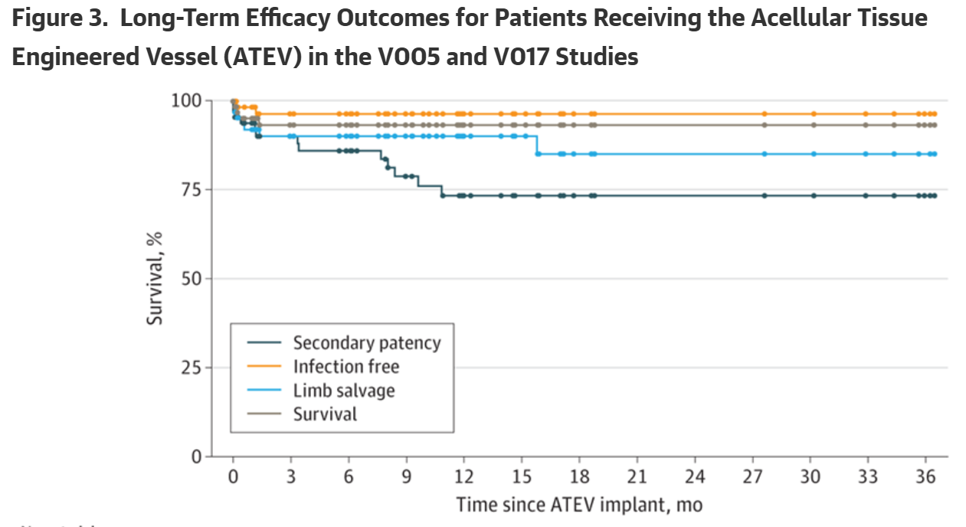

Which, on first glance, looks good! But we have to note that this data includes *both* V005 and V017, and an n=67 (51+16) The graph shows secondary patency is roughly 74% at 12m and beyond. However, they did not choose in this paper to present the individual trial results for V005 and V017. I found this highly problematic because we knew from an August press release (CITE) that the V017 12m secondary patency was 87%. With an n=16, out of 67, this would imply that the results from V005 are in fact **much lower** than V017.

Luckily, with 2 knowns and 1 unknown, we can use simple algebra to precisely deduce the secondary patency of ATEV at 12m in the V005 trial.

This yielded a secondary patency at 12m of **65**% in the V005 study. This is **much** lower than their comparative benchmark from synthetic grafts of 78.9%.

Redrawing the graph for secondary patency with both individual trials would look something like this:

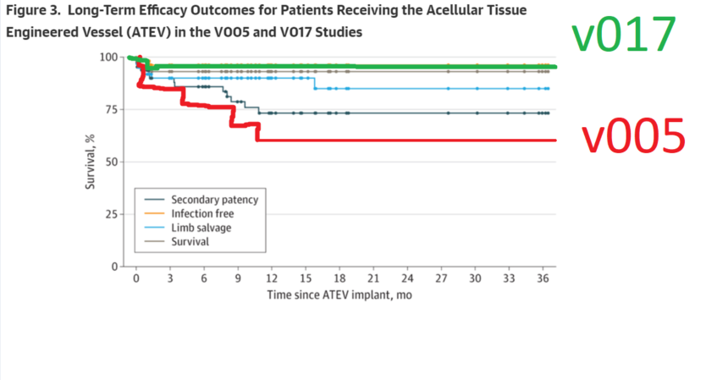

Pardon my drawing skills here but after the data drop, I had thought the data looked suspicious but actually forgot that they had disclosed V017 long term outcomes. Recently a friend (who is long $HUMA) had reminded me of that data, and I was able to deduce the actual patency rate. So V017 should be a bit lower on my graph.

So where does this leave us? Well, we now understand that, for some reason, V017 and V005 have dramatically different results (22% difference). Truly, I don’t know exactly why that’s the case. I can only speculate. I think it’s the baseline health of the patients in each trial that explains the difference, which I’ll get into below.

I also will say that at the recent Piper Sandler conference CEO Laura Niklassen was asked about whether these two trials had a significantly different result (the questioner hadn’t deduced the patency rates for each trial) and Laura responded that “they are not really different, no”.

Look, everyone’s entitled to their own opinion, but that to me is a really disingenuous way to represent these two obviously different data set results. This is flirting with fraudulent levels of misrepresentation.

It’s obvious that there would be a different outcome in patency if you also consider the safety signals.

**Safety data**

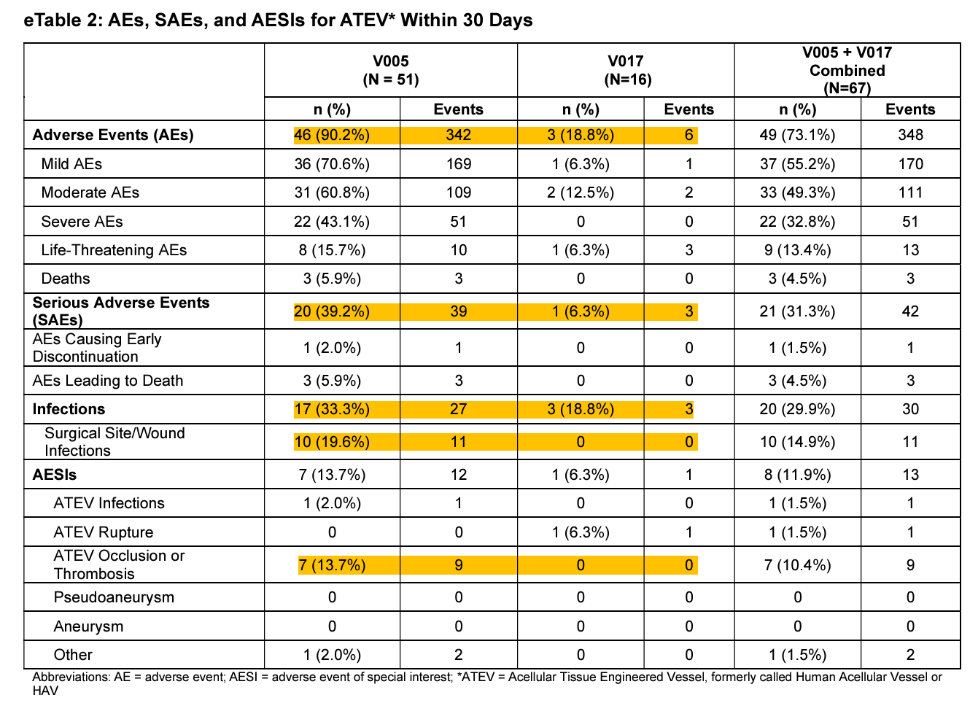We can see from the reported AE data, that the V005 cohort was implicitly much less healthy than the V017 cohort either at presentation in clinic or afterwards. It would be miraculous beyond explanation if they both performed “similarly” from an efficacy standpoint.

Looking at AEs, SAEs (in particular infections) we can see that the patients in Ukraine we just healthier. In terms of how Humacyte shared their amputation and infection data:

* Amputation rate was 9.8% (95% CI, 4.3%-21.0%) and 0% (95% CI, 0.0%-19.4%)
* ATEV infection rate was 2.0% (95% CI, 0.4%-10.3%) and 0% (95% CI, 0.0%-19.4%)
* Death rate was 5.9% (95% CI, 2.0%-15.9%) and 0% (95% CI, 0.0%-19.4%) (no deaths attributed to the ATEV)
* Day 30 synthetic graft benchmarks were as follows: secondary patency, 78.9%; amputation, 24.3%; infection, 8.4%; and death, 3.4%.

Super interesting that they state the confidence intervals here but not for ISS!

* the mean (SD) Injury Severity Scores were similar (V005, 20.8 [10.5]; V017, 20.1 [18.9])

Also, definitely worth noting that they state “no deaths attributed to the ATEV” after the death rate. Was this also true for their comparative synthetic graft benchmark? Well, actually often times yes. But I will save that point for the later discussion. Let’s just compare what we have here.

So amputation rate was much higher in V005, almost 10%, compared to 0% in V017, but lower than their benchmark of 24.3%.

Infection (in the ATEV) was 2.0% and 0%, lower than the reported 8.4% benchmark.

However, death rate was 5.9% and 0%, higher than the 3.4% benchmark.

Very interesting to note the higher death rate (overall survival), possibly due to thrombotic events caused by the ATEV. However, in this data point, as in all data points, we can only really talk about trends since absolutely none of these analyses are reporting any kind of p-value, which to me is pretty egregious in its own right. I get that the study isn’t “powered” and it’s “hard” to run a comparative clinical trial but that’s really not anyone’s problem but Humacyte’s.

We don’t approve products that are “generally” showing a trend. We use statistical rigour to ensure that what we’re observing is repeatable, robust, and not happening by chance. So although the rates are what they are, I take them with a grain of salt.

**Synthetic graft benchmark**

First thing I’ll say is that historical comparisons are always a last resort way to compare two products in a clinical trial. It is very hard to compare two things that were run in different sites, on different people under different conditions at different periods in time. This is a bad way to try and get an approval from the FDA, *especially* in an area that has not had an approval in many years where the standard of care post-graft has been evolving.

I know the FDA is okay with single arm data in some situations, like multiple myeloma, but clinical trials in that particular setting have a much more harmonized clinical trial population from presentation to induction of therapy to years of follow-up and maintenance of the patient through adverse events.

We know really quite well how a 60-70yr old population will react in 3L after having taken the first two SOC treatments. We know how most people react to bispecific antibodies or CAR-T cell therapies. We know how to treat the common adverse events now because we have had multiple independent clinical trials show repeatable results for literally a decade or more.

In this vascular trauma indication, we have a highly disparate “comparator”, some studies are focused on civilian injuries, some are looking in military theatre, upper body vs lower body, some are long term, some are short term, most data in these studies use autologous vein grafts (AVGs), with a few PTFE grafts.

The way we treat thrombosis and post-graft drug regimens have evolved over time and some studies like the VAVIS study have noted that this specific fact (post-surgery prescription drugs) can drastically effect the patency rates, changing outcomes 10-20% in some instances. [CITE] For these reasons in 2024 it’s very difficult to compare to how grafts were treated in 2004, the limit of the lit review as per the FDA. For all these reasons to me a “historical comparison” is literally not approvable.

The notion that this isn’t even feasible to run is untenable as an argument. If you can’t afford the clinical trial don’t pursue that indication. People have a right to safe products in the United States. It’s also already been done with other products on the market such as Artegraft, Gore tex Dacron or PTFE grafts. This is a feasible study design.

Further, Humacyte already tried this approach and it failed in dialysis, validating the above criticism and showing that this company in particular is untrustworthy. After failing their phase 3 non-inferiority study V006 they continued to claim in their slide deck that they may have failed a head to head study but they beat their “historical benchmark”. This is precisely why we run head to head studies and the team’s attempt to rely on that benchmark underscores their attempts to subvert the clinical trial process.

All that being said, to me, the most important factor determining the outcome of the any graft in the short and long term is the severity of injury. In the (Fox, 2005) study, the rate of infection and amputation for the graft was very high. All 5 PTFE grafts had become infected and failed, resulting in amputation. But in the comments at the end of the paper he mentions that having looked at only 1/3 of all the patients the median ISS score was 40 with a range of 16-75. This is double the average for V005 and V017, and remember 60 or above is excluded from analysis in V005. Further, the (Perkins, 2016) paper which is a much larger cohort evaluating 579 extremity injuries actually has this data and showed that amputations happen more often in the higher ISS groups.

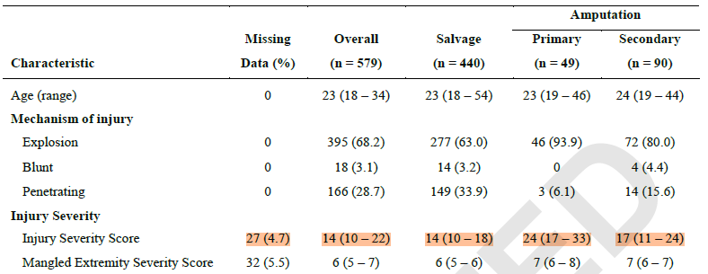

This paper actually seems to be the one where they drew their amputation benchmark from,

Results

The final enrolment for the study was 72, but only 51 total patients were included in the evaluable population. This is because there was a choice to remove the thoracic patients entirely from the analysis and only consider the extremity patients in the evaluable cohort. So the final study V005 relies on the n=52 cohort.

They in their PR on 2023-12-12 reported the following topline data:

|  |  |  |  |
| --- | --- | --- | --- |
|  |  | HAV | lit rev synth graft |
| 30day secondary pat | | 90.20% | 78.90% |
| primary pat (time??) | | 84.30% | NOT POSSIBLE |
| amputation rate |  | 9.80% | 24.30% |
| infection |  | 2.00% | 8.40% |

In their public facing material they do not cite their historical comparisons explicitly. This includes their PRs, their recent slide decks, and any published works on behalf of Humacyte or CEO Laura Niklassen. However, I have dug up an older version of their slide deck from the SEC archives which does cite some of their sources for their claims.

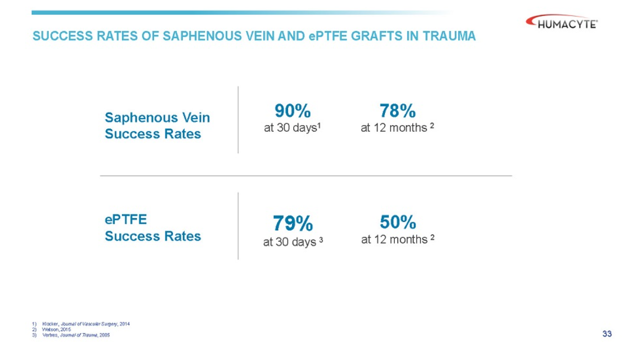

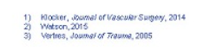

These studies comprise all the content I could find which signalled their “historical comparison”, or “Synthetic Graft Benchmark”. Let’s go through them.



Study 3. Is the key to their claim as it remained primarily unchanged in the efficacy endpoint comparator. This is a single n=14 study that examines the use of a PTFE graft as a tempering intervention in the battlefields of Iraq and Afghanistan to allow soldiers to vascularize their tissues in the short term and then get to a US medical center and receive an autogenous venous graft thereafter.

There was some balance between gunshot (n=6) and blast injuries (n=6), while most injuries were lower body (n=8), some upper body (n=3), and some thoracic (n=3). They state the mean time to stateside arrival was 7 days (range 3-9d), and that within that short period of time 79% of prosthetic grafts stayed patent. 4 cases were presumed to have been infected (28.5%), and it states that no patients require amputation due to graft failure but 3 patients (21%) elected to choose lower extremity amputation due to non-salvageable limbs.

I find this choice of data also surprising as a “historical comparison” when I have found other such studies examining the use of prosthetic grafts in wartime injuries, same as the above Vertrees study. I present this 2020 paper by Haney et al. [4] which examines data from the VAVIS (VA Vascular Injury Study) study [5].

This study was specifically looking at extremity vascular injuries in veterans of the Iraq and Afghanistan conflicts, and how well grafts had performed in the trauma setting. This was a cohort of 527 patients, 140 of which had imaging studies for 143 arterial repairs. Most (52%) were from explosions, and (42%) gunshot wounds. 81% of the 143 repairs were vein grafts and eight repairs 5.6% were occluded, replaced or included in extremity amputations. Patency rates were observed in the cohort:

|  |  |
| --- | --- |
| Patency |  |
| 3m | 99% |
| 6m | 97% |
| 12m | 95% |
| 24m | 91% |
| 36m | 91% |

They then conclude that

*Arterial repair mid-term patency in combat-related extremity injuries is excellent based on imaging studies for 143 repairs.*

Long term data

The biggest concern with the ATEV data released thus far is the long-term data follow-up.

Because this is a military study we can con

For lots of obvious reasons this is not a great comparator arm to base an FDA approval decision off of. I also do not believe it is an earnest attempt to communicate what a literature review would reveal the all stakeholders. To me, this is a deliberate attempt to present favorable data that does not agree with broader published results and it’s a big reason why I’m writing this.

and they have not yet published the full account of the clinical data used in their BLA submission.